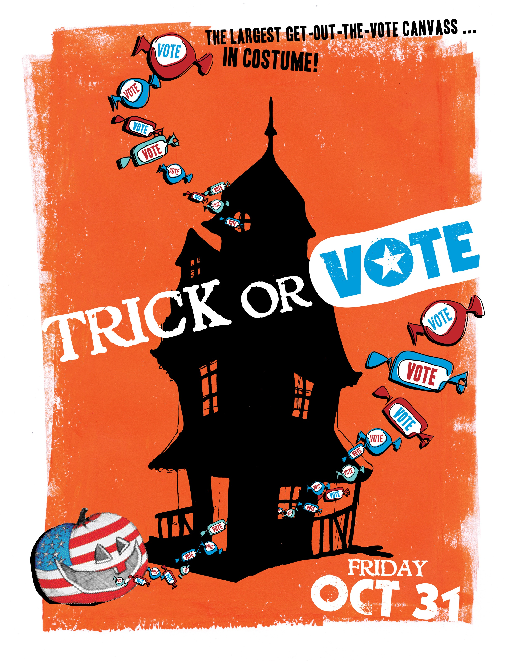

Sponsorship Proposal
Trick or Vote 2008

An opportunity to participate in promoting civic involvement in the newest generation of voters and to associate your brand with a fun and effective way of getting out the vote.

Trick or Vote…Friday, October 31
Leftbank Project, 232 N Broadway
Canvass at 3:30pm and 5:30pm. Party at 8pm.

The nation’s largest nonpartisan get-out-the-vote canvass hits the streets … in costume!

Trick or Vote is a program of the Bus Project. It is a coalition working to make targeted voter contacts in urban areas on Halloween. Just 4 days before the election, 1000 costumed volunteers will canvass low-turnout, youth-dense precincts to remind people to vote, distribute nonpartisan voter guides, and generate both grassroots and media awareness of the upcoming Election Day.

After the massive canvass we’ll gather again for the Ghouls and Goblins Gala, a Halloween bash of epic proportions, and boogie down through the night.

- The best way on the best day: Halloween is the one day each year we culturally expect a knock on the door and it also always falls just days before the election. You may be too old to trick-or-treat, but you're never too old to trick-or-vote. Studies show that face-to-face contact is the most effective method to boost voter turnout—increasing participation by as much as 8–12%.

- Engaging new voices: In 2004, of the 800 volunteers at Trick or Vote, 227 of them indicated with a checkbox that Trick or Vote was their first political volunteer experience.

- Making a Real Difference: In the 2006 midterm election, over 500 volunteers participated in Trick or Vote, knocked on over 20,000 doors, and distributed 25,000 voter guides. Young voters (18-30) in targeted areas turned out at a 5% higher rate than voters in similar, non-targeted areas.

- Nonpartisan contacts increase the likelihood of electoral participation.

Trick or Vote Goes National
Created in 2004 by grassroots powerhouse The Bus Project in Portland, OR, Trick or Vote is going nationwide this year with the help of youth advocacy partners like Rock the Vote, MySpace Impact, United States Student Association, 18 in ’08, League of Young Voters, Forward Montana, New Mexico Youth Organized, New Era Colorado, Washington Bus, Change the Game and Generation Vote.

Now a nationwide affair, the original Portland site will host its 3rd Trick or Vote since 2004. Fifteen other cities across the country, with the support of the Bus and national partners, will begin the Trick or Vote tradition this year.

Ghouls & Goblins Gala
After the massive voter contact effort, the volunteers will gather for a wicked party with local favorites, Blind Pilot & DJ Beyonda, food, drink, a costume contest, a haunted house, and more! Past appearances have been made by Edward Norton, Everclear and Storm Large.

The gala is a thank you party – a recognition of volunteers’ dedicated efforts throughout the election season. General admission tickets will be available to the public. Sponsors will receive complimentary tickets based on their sponsorship level.

The Bus Project

Founded in 2001, the Bus Project has mobilized thousands of volunteers across Oregon, focusing on fun and inventive ways to engage young people in the political process.

The Bus Project is an innovative vehicle for hands-on democracy. We drive votes, drive leaders and drive change (and yes, we have a bus). Dedicated to people-powered politics, we’re building a movement—not left, not right, but forward.

The Bus’ nonpartisan voter registration machine, Building Votes, aims to register and turnout over 20,000 young voters for the 2008 election cycle, having already registered almost 15,000 voters this year. Building Votes has registered almost 40,000 voters since 2006.

Both the Bus Project Foundation and Trick or Vote conduct nonpartisan, 501c3 activities. All donations are tax deductible.

Hands On Greater Portland

A prominent Trick or Vote partner, Hands On Greater Portland, has selected Trick or Vote as the “October Focus” for the Hands On Community.

Hands On Greater Portland serves the community as the premier cache of volunteer opportunities. They connect potential volunteers with opportunities, and strive to illustrate, with each volunteer engagement, the direct impact in the community and the spread of awareness of community needs. Formed in 1996, Hands On Greater Portland makes over 13,000 volunteer connections each year, in partnership with over 200 nonprofits, schools and community organizations. This connection will generate even greater community awareness of Trick or Vote.

Media

Trick or Vote has already seen success on the national stage. Volunteers dressed as monsters attended both the Democratic and Republican National Conventions where they made quite a splash. From the Huffington Post to MSNBC to CBS, the press was smitten with Trick or Vote and the enthusiasm of our volunteer monsters. In Denver, Katie Couric interviewed a Devil and Angel duo promoting Trick or Vote.

On the local stage, Trick or Vote is pleased to have Willamette Week on board as the main media partner. Trick or Vote will appear in two quarter-page ads and a featured online campaign.

REACH YOUNG PEOPLE.
1000 volunteers will knock on 30,000 doors in youth-dense, targeted areas.

ONLINE PRESENCE.
Blast email distribution of 15,000 in Oregon & 100,000 nation-wide. Printed materials drive traffic to local Facebook & MySpace pages.

SPONSORSHIP OPPORTUNITIES:

Presenting Sponsor, $10,000+
- Name/logo included as presenter of Trick or Vote
- Name/logo included in all blast emails. (Distribution of 15,000 in Oregon & 100,000 nation-wide).
- Logo included on all print materials including posters, handbills and other promotional materials as presenter of Trick or Vote
- Name/logo on Willamette Week ads.
- Name/logo listed on: MySpace, Facebook & Bus Project website.
- Name/logo mentioned in all press releases as presenter of Trick or Vote.
- Name/logo on canvass bags for all volunteers as presenter of Trick or Vote.
- On screen recognition at Gala & 8 free tickets.
- Product placement in volunteer ‘goodie bags’ at Gala.

Democracy Sponsor, $5,000+
- Name/logo included in all blast emails. (Distribution of 15,000 in Oregon & 100,000 nation-wide).
- Name/logo mentioned in all press releases.
- Name/logo on Willamette Week ads.
- Name/logo listed on: MySpace, Facebook & Bus Project website.
- On screen recognition at Gala & 6 free tickets.
- Product placement in volunteer ‘goodie bags’ at Gala

Civic Sponsor, $2,000+
- Name included in all blast emails. (Distribution of 15,000 in Oregon & 100,000 nation-wide).
- Name mentioned in all press releases.
- Name listed on: MySpace, Facebook & Bus Project website.
- On screen recognition at Gala & 4 free tickets.
- Product placement in volunteer ‘goodie bags’ at Gala

Get Out The Vote Sponsor, $1,000+
- Name included in all blast emails. (Distribution of 15,000 in Oregon & 100,000 nation-wide).
- Name mentioned in all press releases.
- Name listed on: MySpace, Facebook & Bus Project website.
- On screen recognition at Gala & 2 free tickets.

All Sponsors at all levels will be thanked in emails and print materials distributed to all volunteers.

All Sponsors will have helped promote the habit of voting and civic engagement in the newest generation of voters, as well as used to the most efficient methods to raise youth voter turnout.

Questions? Contact: Clare Seekins at 503.233.3018

National Partners

“Getting Out the Youth Vote: Results from Randomized Field Experiments,” by Donald Green & Alan Gerber, Yale University, 2001.

